Home page

Error 1:
This button has no function
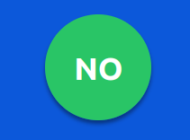

Error 2:
The word click seems like a link but don’t do anything.

Error 3:
Then u see HERE word is actually the real link but it hasn’t any mouse appearance change, so you will not know that’s the link till you click on it.

Error 4:
Same as the first error, it seems like a link, but it isn’t.

4 Forms page:

Error l:
You can’t reach the 4 forms, if it gets you more than a minute to pass to the next form, the page will stop you.


Error 2: The “next“ button is useless, same as “reset” button.

Error 3: Your password needs my mom’s name too.
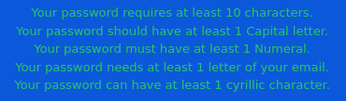

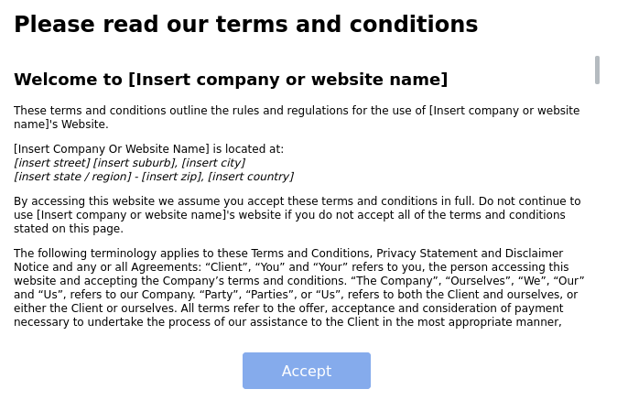
Error 4: You can’t scroll faster than 1 paragraph per hour.

Time-pop up and help windows:

Error 1: You can only lock it or expand it, so you can’t use the page anymore.
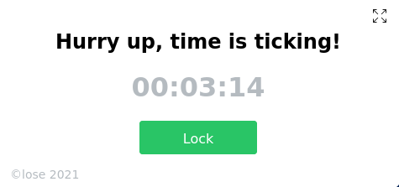

Error 2: This button only allows you to expand A LOT the help windows till it’s impossible to grow up more, then it goes down until it disappears.



Error 3: The “Send” button has the function of making smaller the help windows, and doesn’t allow you to send anything.
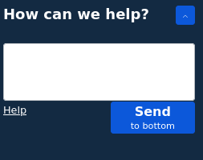

Error 4: The word “help” that’s on the bottom-left side of this window only show to you this:


This page is useless but at least is funny.

